Football Association of Ireland

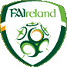

White Paper on the Strategic Direction
of the eircom League

CONFIDENTIAL

Presented by

GENESIS
Strategic Management Consultants

19 September 2005

Table of Contents

1. Executive Summary 3

2. A brief history of the eircom League 5

3. Current state of the league 6

4. Key External Factors 9

5. Rationale for Change 12

6. Vision of Success 13

7. Recommendations 14

8. Next Steps 21

Appendix 1: Comparator Review of Other European Leagues 22
Appendix 2: UEFA and FIFA Rankings 28
Appendix 3: The External Environment 37
Appendix 4: Options for League Structure 40
Appendix 5: List of those Consulted 42

Executive Summary
Over the last 20 years the eircom League and its member clubs have struggled to survive. By any rational analysis of financial performance, attendances and sponsorship it is clear the eircom League is near to being economically bankrupt and is unsustainable in its current format and incapable of sustaining itself into the future.

The competitive environment for sport in Ireland is strong and getting stronger and soccer at Senior level is losing out. To compete effectively, sports must have a strong, attractive product and deliver genuine entertainment to spectators, value to sponsors and a quality environment for players and coaches. Changes in soccer in Europe and the UK are also contributing to what is an ever more challenging environment for the eircom League, its clubs and players.

The League is dislocated from the rest of football and not something to which young Irish players aspire. The current League does little to support the implementation of the recently published Technical Development Plan for soccer in Ireland. The League’s management structures and processes have not modernised, far less achieved the effective changes made recently at the FAI. Other Irish sports e.g. Greyhound Racing, GAA, Rugby Union have reinvented themselves and comparator soccer leagues in other nations (e.g. Austria, Norway) demonstrate higher levels of performance. The current League languishes in 40th place (out of 52) in UEFA league rankings, in marked contrast to the Irish national team which has been consistently in the top 20 in the world.

The eircom League is currently trapped in a downward spiral. A poor product with unattractive facilities leads to a lack of support, minimal sponsorship and low levels of income. The challenge for the league is to shift from that downward spiral to a virtuous, growing spiral where a strong, superior product with attractive facilities leads to increased support, higher levels of sponsorship and an improvement in performance and income for the league and its clubs.

We have carried out an extensive consultation with all stakeholders in the game to establish their views. In particular, we sought to engage with all strands of the game including the clubs, supporters, players, sponsors, broadcasters, media, amateur and schoolboy leagues. Every grouping was given a chance to have their say and express their views and ideas.

Making small, incremental changes to the League will not have the desired effect. Transformation is required to change structure, management, performance and behaviour - all four vital ingredients of any process of change. What is needed is a “whole new ball game”.

This report outlines a vision of success for the League by 2010, which we believe is possible, given commitment to change. It recommends proceeding with the proposed merger between the FAI and the League. The league should be run for the benefit of football in Ireland and the FAI is best placed to deliver on this. It also recommends the creation of a 10 team elite league for the eircom League, with 2 regional leagues, each of 10 teams, providing the route into the top division. It affords the opportunity for 8 clubs to join the new regional league structure. This structure should be supported by investment in the clubs, their people, stadia and facilities. Clubs will be invited to join the League and required to sign a participation agreement which, when implemented, will do much to assure a quality product for spectators, sponsors, players and coaches. We further recommend that significant development work be undertaken in support of the League to ensure that the League clubs form a valued and integral part of their local communities. This local activity will go a long way to assuring support for the clubs and attracting higher and more sustainable attendances. The League and its clubs will need to market the League and its fixtures much more assertively, something that its current poor product does not allow.

The revised strategy for the League will require investment. The source of funding for this investment will come from four key areas:
- FAI (Grants, Sponsorship etc.)
- Public funding (Government and local authorities)
- Clubs
- Private Investment

We believe the recommendations, when implemented, will provide the basis for a successful and more sustainable environment in which the eircom League can flourish.

A brief history of the eircom League
Foundation of the League
The League of Ireland was originally founded in 1921. A total of eight clubs competed for the first championship, won by St James Gate. Of the original founding members, two clubs are still competing within the eircom League (Bohemians and Shelbourne).
Membership of the league fluctuated over the next sixty years until 1985 when the league was split into two divisions (Premier and First Division) with 22 clubs, as there is today.

From the highs to the lows
In the 1960s and 1970s the League of Ireland reached the height of its popularity with clubs commanding crowds in their many thousands. Since then, the league went into decline and many clubs struggled to make ends meet. Shamrock Rovers, for example, were forced to sell their home, Glenmalure Park and attendances dwindled considerably with average attendances in the league now measured in hundreds rather than thousands.

International Team v The League – Chalk and Cheese
In the same period the international team has flourished. Since qualifying for its first major finals in the European Championships of 1988, Ireland has consistently punched above its weight on the international stage (both at Senior and Under Age levels). The Ireland team attracts large support, generates huge interest and has climbed the world rankings.
In comparison, league clubs have performed poorly in European competitions, with few highlights, such as Cork City’s current campaign, St Patrick’s Athletic narrowly losing to Glasgow Celtic, and Shelbourne’s exit to Deportivo La Coruña, last year at the final qualifying round for the Champions League.

Where to for the League?
Recently, the league has seen the introduction of summer football and some clubs are attempting to establish full-time professional squads. Whilst the overall standard of football and skill levels in the league is improving, the clubs continue to struggle to survive.
It is against this context that an extensive consultation exercise has been conducted to review the current state of the eircom League and develop a strategic direction for the future.

Current state of the league
By any rational analysis it is clear the eircom League is not working. In our view, the league in its current format is unsustainable. Whilst some progress has been made in certain areas, against all major performance indicators the league is under-performing.

Finances
From a financial perspective, every league club is struggling to make ends meet, and most clubs are running on operating losses, year on year. The eircom League clubs generate an annual turnover of approximately €14 million. However, the total annual losses of the clubs amount to over €3m, funded in large by Director loans (i.e. individuals putting money into their clubs to keep them going). These cumulative losses are threatening the very survival of several clubs and the prospect of administration and bankruptcy is now a reality for eircom League clubs. Individual benefactors will not continue to plough increasingly larger amounts of money into clubs with no prospect of any return on their investment/donations. It is inevitable, therefore, that if this situation continues, several clubs will go out of business over the next few years.
Similarly, league revenue is pitifully low in comparison to other European leagues. Currently, the majority of league funding comes via the FAI, in terms of grants and sponsorship income. Last year, 2004, the league generated €1.43 million in revenues of which only 40% came from outside of the game itself (i.e. 60% of revenues are generated from club fees, fines and grants). Prize money for winning the league last year was a paltry €18k (the winners of the inaugural Setanta Cup received €150k).

Sponsorship
The eircom League attracts less than 1% of the total sports sponsorship market in Ireland. It is clear that sponsors do not regard the league as an attractive sponsorship vehicle in its current guise. This coupled with the frustration that some sponsors expressed in having to deal, effectively with 22 clubs rather than at a pan-league level, contributes to the low levels of sponsorship support for the league.

Attendances
Weekly attendance figures, whilst improving over the last 2 years, are still low and unable to provide sufficient income for sustained growth. The average attendance at a Premier division game is 1,800, and the First division it is 500. This is low relative to other European leagues of a similar size/scale (see Appendix 1).
Similarly, when compared with other sports, the eircom League attendances (under 400,000 in total last year) trail, by some distance, the attendances at other events - the GAA Championship (2.2m), Celtic League (424k), Heineken Cup (815k), Greyhound Racing (1.39m) and Horse Racing (1.3m) attendances.

Facilities
In certain cases facilities in clubs have improved, however the facilities at many league clubs are inadequate and outdated. In many grounds basic facilities are not in place or are sub-standard. The state of the grounds acts as a strong disincentive for families to attend league games. Facilities in other sports in Ireland have seen considerable investment. For example, greyhound racing has successfully transformed its image over the last ten years and importantly provides high quality facilities for its customers. Government funding for improvements in facilities is available and this is to be welcomed. However, a major improvement in basic facilities at league grounds is required across the board. As one interviewee suggested “It’s hard to persuade people to come and sit in a dump!”

League Ranking
The eircom League UEFA ranking, determined on the basis of the sum of the UEFA country coefficients over the last 5 years, shows Ireland in a lowly 40th place out of 52 countries (see Appendix 2). Given the strength and popularity of football as a sport in Ireland and the high ranking of the International team (until recently 14th in the world) this is a significant under-performance. The list of countries immediately above Ireland in the league rankings illustrates this point. Belarus, Liechtenstein, Iceland, Macedonia, Lithuania, Georgia, Moldova, Finland, Latvia and Bosnia-Herzegovina are the 10 countries ranked immediately above Ireland. With the exception of Finland (43rd) none are in the top 50 countries in the world. None have a tradition of an established professional football league.

Marketing
The marketing of the league is low key. In comparison to what other sports offer, the eircom league is some way behind. For example, the GAA football and hurling championships, rugby’s Heineken Cup, various horse racing events and major golf events are all marketed and presented in a high profile, highly polished manner. There is no sense of occasion/event associated with league football, nor is there any effort made to create ‘stars’ out of players within the league. The promotion of the game lacks consistency. Up until the launch of Summer soccer there was no marketing budget allocated to the promotion of the league and last year that amount allocated was just over €100k.

The League and the rest of football
The eircom league operates somewhat in isolation and is perceived to be dislocated from the rest of the game. The relationship with amateur and schoolboy leagues can be fractious. Player compensation is seen as a major issue and an impediment to establishing better working relationships between the league and amateur/schoolboy leagues.
Many league clubs have little or no involvement with their local communities. With one or two notable exceptions, there are few initiatives in place to foster and develop relationships in the local community and therefore no spirit of loyalty to the ‘local’ league club exists.
League players have had no realistic presence in the International squad over the last twenty years. Of the 2002 World Cup squad, only Roy Keane, had played senior football in the National League.
The league as it currently stands is not the pinnacle of the domestic footballing pyramid and few young players aspire to ‘make it’ with a league club. The FAI’s Technical Plan needs the league to be the top of an integrated structure for the domestic game, rather than an island operating in isolation of the other strands of the game in Ireland.

The Clubs
As outlined above, most of the clubs are financially unstable. Many clubs are living beyond their means and with a few exceptions prioritise expenditure on players over development, improvement or investment in other aspects of the operations of the club. Whilst we did not have access to the detailed financial records of clubs, we believe a large number of clubs are operating with players’ expenses to sales/turnover ratios in excess of 80%. As a result, clubs are having to paddle harder just to stay afloat.
In general, there is a severe lack of professionalism in the management and administration of clubs. They lack marketing and PR expertise and there is little evidence of long-term planning and focus within the clubs. It is no surprise that clubs are not in a position to plan for the long-term when they are focused on operational survival in the short-term. The clubs, therefore, operate on a week-to-week basis going from hand to mouth.

Media Coverage
The media coverage of the league is mixed. Press coverage of the league is strong, relative to attendances, with all of the national newspapers featuring the league prominently. Regular reports are carried on all games and there are considerable preview/opinion articles in the various newspapers. Likewise, the radio coverage on a National basis is very good. However, television coverage is disjointed. There is no regular pattern to the TV coverage and it is not promoted/marketed effectively. As a result, whilst a ground-breaking TV deal involving all four TV companies was negotiated this season and there is more live coverage of domestic football than ever before, the impact of TV coverage is diluted. Coupled with this, the saturation coverage of English Premiership and Champions League football sets standards and expectations for the quality of coverage that are not matched. Low attendances and poor positioning within grounds for TV cameras makes the presentation of eircom league football look amateurish.

League Management Structures
The league is governed through a Management Committee and a Board of Control, and run by a professional staff of eight. The Management Committee is made up of 22 members - one from each league club - and the Board of Control has 10 representatives, nominated by the clubs. This structure ensures that decisions are made with the clubs’ interests at their heart rather than being taken in the best interests of football in general. The majority of those consulted highlighted this as a major weakness and it our view that this structure has been a major contributing factor to the under-performance of the league. It needs to be changed.

League Staff
The full-time professional league staff operate in limbo. They are, effectively, paid by the FAI but are not employees of the FAI. The league office is located in Merrion Square, in temporary accommodation. The improvements in the management processes within the FAI over the last year are not reflected in the league staff. They do not have formal contracts or performance reviews, and there are some grey areas in terms of reporting lines.

Key External Factors
The external environment affecting the eircom League has changed dramatically over the last number of years. These changes have implications for any strategy for the league. We have summarized briefly what we see as the key trends. A more detailed analysis is contained in Appendix 3.

Shifting trends in football
Fundamental changes have taken place in the wider world of football over the last ten years that have a major impact on the environment in which the eircom League must operate:
- Major increase in the commercialisation of football
- Saturation coverage of the English Premiership and Champions League
- Bosman ruling – less money for smaller clubs, more movement of international players
- Major investment in facilities and stadia
- Rich getting richer, the poor getting poorer (leagues and clubs)
- Intensifying competition for Ireland at International level
- Active following of English Premiership and Scottish Premier League clubs in Ireland.

Changes in the UK
The professional leagues in the UK are undergoing specific changes which are directly relevant to the eircom League:
- The English Premiership is the richest domestic league in the world
- Huge influx of foreign talent (on average 12.6 players per club)
- UEFA acting to regulate home grown players – limiting opportunities for Irish players in the UK
- The numbers of Irish youngsters going to English clubs are falling
- Wage expectations of players lowered considerably.

UEFA Perspective
UEFA are increasingly taking more regulatory control in the affairs of domestic football in Europe:
- Club licensing raising the bar in all aspects of operations. The next round of UEFA licensing (to be announced in October) is likely to see standards to be raised and tightened even further.
- UEFA taking a strong stance on the running of domestic leagues
  - Striving for National Associations to control domestic leagues
  - A pyramid structure with the league at the pinnacle
  - Setting development of club football as a key priority
  - Adopting a more interventionist strategy.

The competitive environment in Ireland
The eircom League is competing with a range of strong/revitalised sports in Ireland.
- GAA
  - The GAA has reinvented itself and is in vogue
  - High quality branding and marketing
  - Strong attendance figures
  - Extensive media exposure
  - Maintained their strong community links.
- Rugby
  - The IRFU has effectively embraced the professional era
  - Crucially, it has maintained control of its players
  - Extensive coverage on TV
  - Strong provincial structure
  - Strong attendances at professional level.
- Greyhound Racing
  - Bord na gCon has overseen a dramatic transformation
  - Significant upgrading of facilities
  - Implemented focused and highly successful marketing strategy
    - Captured a new target audience
    - 1.385m attending meetings in 2004
    - Sponsorship income up considerably.
- Horse Racing
  - Ireland has a strong, sustainable Horse Racing industry
  - Courses are investing in their facilities
  - Attendance levels are high
  - Commercial sponsorship continues to rise each year
  - Prize money is rising rapidly.

Key Lessons from other Leagues
We carried out a detailed comparator review of other European soccer leagues and other sports. The soccer leagues included Austria, Belgium, Denmark, Israel, Norway, Switzerland and Australia. All, bar Australia obviously, are ranked higher in the European league rankings but all the countries are ranked lower than Ireland in the FIFA World Rankings. None are in the top tier of European leagues. Appendix 2 includes some of the key comparator data.
The key points to emerge from this review are:
- With the exception of Norway, all of the leagues have higher populations per National League team than Ireland.
- There is a mixed performance in terms of growth in attendances – Austria, Norway and Switzerland are displaying strong growth but Belgium and Sweden’s attendances fell last year.
- Most of the leagues have two divisions and in all cases the second division has at least the same or more teams than the top division.
- All of the leagues except Australia, which operates on a franchise basis, are open with promotion and relegation into/out of the league.
- The Norwegian league was highlighted as having special interest by many observers. The key success factors of the Norwegian league are:
  - They sought to have the clubs behave as if they were professional without being full time pros. Clubs train in the mornings with players working in the afternoons/evenings.
  - They invested heavily in high quality coaching and facilities (e.g. training, pitches, stadia etc.).
  - The league is marketed strongly.
  - There is a clear focus on keeping and developing the best talent and only exporting them to other leagues (e.g. EPL) at a later age. As a result they keep the best young talent in the league longer.
  - Attendances are relatively high and sustainable, with an average of 9,500 and growing (20% last year) in the top division.

Finally, we also examined other sports that have enjoyed strong growth in their leagues. Specifically, we found some key lessons in Rugby Union and Cricket in the UK:
- Rugby Union – Guinness (Zurich) Premiership
  - Focused development strategy for the league based on:
    - Creation of identity (teams and individuals)
    - Sense of occasion – more than just a rugby match
    - Significant upgrade in facilities, in many cases without significant capital investment (e.g. London Irish (Madejski Stadium)
    - Significant exposure through Sky Sports
- 20/20 Cricket
  - Created a completely new product to revitalise interest in county cricket
    - Focused targeting strategy to attract a new audience
    - Creation of atmosphere and theatre
    - Sexed up the game
    - Innovative alterations to how the game was played.

Rationale for Change
The picture presented above is stark. The league is financially weak and struggling even to maintain its current financial position. The competitive environment for sport in Ireland is strong and getting stronger. Changes in football in Europe and the UK are also contributing to what is an ever more challenging environment for the eircom League.

This is, therefore, make-or-break time for the league. In our view, tinkering through a number of small changes will not produce the required transformation in the fortunes of the league and its clubs. There is a need for a radical overhaul of the eircom League.

This should address all areas:
- Management structure
- League structure
- Facilities
- Marketing
- League revenue model
- Club administration
- Wage control
- Development
- Links with amateur game
- Community links
- Participation agreements
- Dispute mechanisms.

Vision of Success
There is so much potential for improvement in the performance of the eircom League. What might a successful outcome for the eircom League look like in five years’ time? We believe the following is possible and represents a realistic vision of success:

Ranking:
- Top 20’s in the UEFA League rankings
- League clubs are consistently competitive in Europe and competing in the Champions League group stages
Attendances:
- 1 million per annum with an average 4,000-5,000 per game
- Successful clubs in all major population centres
Facilities:
- Range of 5,000/10,000 all-seater stadia throughout the League
- High quality facilities including corporate hospitality, catering and conference with the stadia working 7 days a week
- Facilitate the creation of ‘an event’ around game night
- Pitches meet International standard and high quality training facilities
Licensing:
- All clubs adhere to licensing requirements
- Range of high criteria set for participating clubs
Club Management:
- Professional management & administration in clubs with a long-term planning focus
- Clubs stable, solvent and investing in infrastructure and development
- Clubs managing within their means (Wage/turnover ratio 65% or less)
Media Coverage:
- High profile coverage across all media (TV, Radio, Print, Digital)
- Weekly live and highlights TV coverage of games
- Players recognised and personalities created
Playing Standards:
- League players regularly in International Squad
- All coaches fully qualified
- High quality, competitive football, with full time professional squads
Marketing:
- League is ‘sexy’ and ‘cool’
- High quality branding and marketing, attracting premium sponsors/partners
Pyramid:
- League is the pinnacle of the football pyramid with a clear pathway from under-age, youth, senior leagues and partnership with all of football
- Young players aspiring to play in the league and the clubs developing their own talent with successful National underage leagues in place
Community:
- Strong identity between clubs and their communities
- All clubs/schools in the area are attached to their local ‘league’ club
- Club is the focal point for the community it serves
League Management and control:
- Long-term, strategic focus
- Strong, decisive, independent and direct guarantor of excellence
- Detailed participation agreement/contract in place and adhered to
Financial Strength and Stability:
- League generating significant revenues - €5-10m
- Attracting investment form Government, Private Investment
- Top League clubs with annual turnover of €3m+ and financially stable

Recommendations
The eircom League is currently trapped in a vicious downward spiral. A poor product with unattractive facilities leads to a lack of support, minimal sponsorship and low levels of income. The challenge for the league is to shift from the downward spiral to a virtuous, growing spiral where a strong, superior product with attractive facilities leads to increased support, higher levels of sponsorship and an improvement in performance and income for the league and its clubs.

The opportunity exists to be radical. Football is the world’s leading sport and has the highest participation of any sport in Ireland. Ireland is still succeeding internationally and punching above its weight. There is unquestionably a latent support for a high quality league as evidenced by the high levels of interest in recent European club games. The Irish economy is forecast to continue to grow strongly, ensuring an environment in which ongoing investment in Ireland’s leading participation sport should be forthcoming.

There is an increasing realisation by all stakeholders in the game that something needs to be done. As outlined above, this will require fundamental changes to how the league is structured and managed. We have listened carefully to all of the stakeholders within the game and reviewed experience in other leagues. As a result we strongly recommend the following:

League Merger
The proposed integration of the league within the FAI appears to have widespread support from the various stakeholders within the game. Many believe that the league will have a better chance of success if it is formally managed as part of the FAI. We agree with this viewpoint and believe there are a number of other reasons for supporting the proposed merger:
- The role of the FAI is to manage the game for the benefit of football in the country. The eircom League is a key component to that and it should be managed from the perspective of and for the greater good of the game in Ireland. The FAI is best placed to ensure that this happens.
- The FAI has shown they have the potential of attracting increased revenue through sponsorship and marketing for the league. Increases in prize money for the league, the Setanta Cup, recent sponsorship deals, and the TV deal are all examples of this.
- Government funding will only be allocated through the FAI. The ability of the league to attract public investment will be enhanced if the FAI is formally running the league.
- The eircom League is a central cog in the FAI Technical Plan. It is critical that a strong domestic league acts as the pinnacle of the football pyramid and pathway to create an integrated development structure. The league is of key strategic importance to football in Ireland.
- There are undoubtedly economies of scale in various areas of operation including Finance, Marketing, Human Resources and Club Licensing.
- UEFA are strongly advocating National Associations to have full control of domestic leagues.
- The League staff are effectively employees of the FAI already. The merger would formalise this and provide an improved organizational environment for the staff.
Given the level of support expressed through the consultation process we believe the FAI should proceed with confidence with the proposed merger.

Management Structure
The current management structures of the league should be revised. The existing Management Committee and Board of Control should be replaced by an Executive Board of no more than 8 individuals. The Board should be objective and independent. The make up of the board may include the following:
- League Chairman
- FAI Director (with executive responsibility for the League)
- Club representatives (3)
- Sponsor representative
- Independent Director (preferably with extensive marketing experience).
The Board will be responsible for the strategic direction of the League and will be the primary decision-making body.
An annual League Congress will be held with all participating clubs having representatives at the Congress. This will be a discussion and information sharing forum on league matters and will provide the opportunity to put ideas forward for consideration by the Board, but will not have any formal decision-making powers. The club representatives on the Board will be elected each year at the annual League Congress.
Also, a players, managers and referees panel should be established to act as a mechanism for getting the views of both players, managers and referees on a regular basis.

League Structure
A number of alternative options were considered for the league structure, ranging from maintaining the status quo to more radical restructuring of the league. Appendix 4 contains a brief overview of the options identified and considered. The key issues in developing the various options for the design of the league structures were:
- What is the optimum number of teams in the league?
- Should the league be open or closed?
- How many tiers should there be to the league?

We developed a list of ten criteria for evaluating the various options:
  - What is best for football in Ireland
  - Optimise the commercial potential of the league
  - Improve the competitiveness of clubs in Europe
  - Provide high quality football (“the best of Irish”)
  - Represent a new beginning for the league
  - More attractive for public and private investment
  - Provide a pinnacle for the development pathway for the game locally
  - Support the strengthening of the international team
  - Minimise costs of participation for clubs
  - Provide an adequate geographic spread of league clubs.

Our preferred option has the following features:
- A single National League of 10 teams
- Two Regional leagues below the National League with 10 teams in each Regional League
- There would be promotion and relegation between the top league and the Regional leagues via an end-of-season play-off system
- Both the National and Regional leagues would be played in the Summer
- There would be a promotion and relegation mechanism between the Regional leagues and the Amateur leagues
- Minimum criteria would be set for participation in the National League
- The National League will be made up of full-time and part-time professional clubs
- The Regional leagues will be made up of part-time professionals, amateur and representative sides
- All amateur/schoolboy leagues and clubs will be associated with/attached to a National or Regional league club/team.
- Dual registration of players will facilitate the success of U21, U18 and amateur and representative sides.

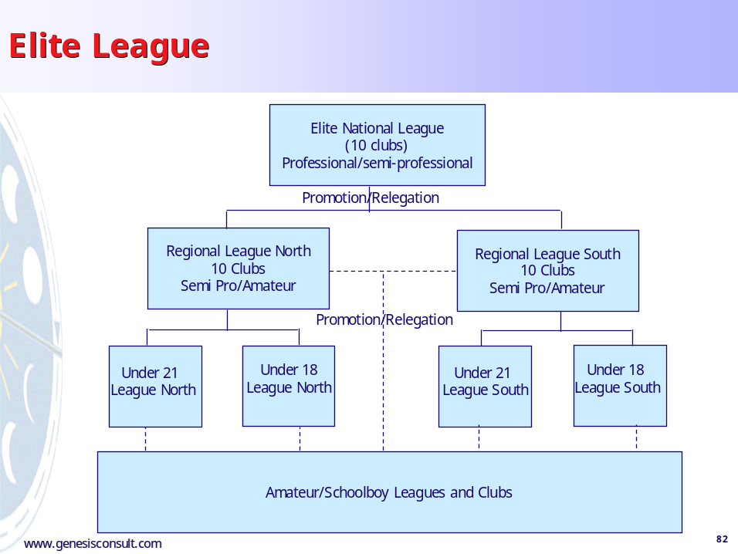

In our view, the League can only sustain a maximum of ten clubs at the top level to ensure that there is sufficient competition between teams, playing talent is concentrated in fewer clubs, a more focused facilities investment programme can be pursued and clubs can attract sufficient levels of support. Ideally, the ten clubs in the National League will be spread across the major population centres throughout the country.

The Regional League structure offers those clubs outside the National League a lower cost base from which to operate and a greater level of ‘local’ rivalries and interest in their games.

Of the current 22 clubs, 10 will play in the National League and 12 will play in the Regional Leagues. That means a minimum of 8 additional teams would be required to participate in the Regional Leagues. Priority should be given to representative sides from across the country. For example, the Kerry or Mayo County League could nominate a representative side from within its playing members to participate in the Regional League. This will strengthen the regional link to the teams and also create a closer link between the amateur league and the National league. The Under 21 league has shown that this can work. Any expansion of teams outside the current league clubs should be done through this representative model.

We recommend that the feasibility of an All Ireland league should be explored with the various stakeholders in the game, including external bodies such as UEFA and the IFA. Whilst in the short-term there are many barriers to be overcome for an All Ireland league to be established, we believe that the option outlined above would be consistent with, and facilitate a move towards, an All Ireland league should this become a real possibility.

Participation Agreement
A detailed participation agreement should be drawn up for all league clubs. The participation agreement will be based on the principle of a contract and will contain clear obligations for participating clubs. The clubs will be invited to apply for membership of the league and must sign the participation agreement and be bound by its contents. The agreement will be strongly linked to the club licensing scheme and consistent with club obligations within that scheme.
The agreement should cover aspects like:
- The League, Membership rules, Promotion/Relegation, Play-Offs, Becoming a member, Ceasing to be a member, Expulsion, Resignation, Relationship between Clubs and the League
- Finance including obligation of the League and the clubs, wage control, accounting practice, operating and other expenses, distribution of league revenues, power to deduct, submission of club accounts, power to inspect, UEFA club licence obligations
- Fixtures including arranging, rearranging, postponement, failure to play, replaying, other competitions, match delegate, full strength teams, team sheet, substitutes, use of official ball, technical area, penalties, etc.
- Player identification and strip including home and away and advertising
- Match officials
- Medical personnel
- Ground criteria, including safety certificates, ownership of ground and training facilities, ground regulations, facilities (dressing rooms, media, the pitch, technical areas, floodlights, sanitary facilities etc.)
- Managers including code of conduct, coaching qualifications, contracts, registration, pre-season meeting, dispute resolution etc.
- Players including approaches to/from players, public statements, inducements, contracts, fines, dispute resolution, registration, etc.
- Youth development
- Disciplinary procedures and arbitration.

Facilities
There is a need for considerable investment in facilities in all league clubs. However, investment should be prioritized on the clubs with clear strategic plans and planned outcomes. Investment in facilities should be prioritised in top National league clubs and/or clubs serving large population centres. The facilities investment should include provision to ensure high standards of:
- Floodlights
- Playing surface
- Training
- TV and media provision
- Family friendly facilities
- Seating
- Toilet and other facilities
- Catering/hospitality
Ultimately, the planned programme of investment in facilities should deliver a range of high quality, family friendly stadia and clubs across the main population centres and strongholds of football throughout the country. The facilities should be equipped to support the clubs in providing revenues outside match days.
It is inevitable that Dublin clubs will be encouraged to consider ground-sharing if they are to attract significant public funds for investment.

Marketing
The league should be re-branded and re-launched as part of a revised marketing strategy. In re-branding the league, we believe the key attributes that should be emphasised are ‘Irish’, ‘Professional’, ‘New’, ‘Different’, ‘Quality’, ‘Premium’, ‘The Best of Ireland’.
Some Possible Names for the new League:
- eircom Professional Super league
- eircom Elite Irish League
- eircom Ireland Super League
- eircom Irish Premiership
- eircom FAI Premiership.
A significant marketing budget should be set aside to support, promote and market the league strongly. Efforts must be made to ensure there is a partnership with TV and the media in general to deliver the re-branded league and to present the league in a consistent manner. Consistent branding should be implemented in all grounds to ensure a common presentation, and look and feel at all grounds. The league will need to work closely with sponsors and partners to deliver on the marketing strategy. The merger of the league with the FAI will facilitate a more integrated league from a sponsor’s point of view. Clubs must work closely with the league to ensure there is a consistent brand identity established, obligations to sponsors are delivered efficiently and an integrated marketing campaign is executed throughout the league. A strong partnership relationship with sponsors is critical to maximise the benefit to the League. Rugby’s Heineken Cup and the Guinness sponsorship of the GAA Hurling Championships are excellent examples of how sponsors, working very closely with the rights holder, can help transform the product to the benefit of all involved.
Club Administration
For the league to work, the clubs must be managed to high levels of professionalism to raise the overall standards. Clubs should operate against long-term plans with a clear focus on planned outcomes.

The clubs must possess strong skills in:
- Leadership
- Strategic planning
- Finance and Administration
- Marketing and PR.
Where appropriate, assistance should be provided to clubs to help build and develop their capabilities in these areas.

Wage Control
A mandatory wage control mechanism should be put in place for all clubs within the National League. Clubs should be limited to spending 65% of turnover on players’ wages and costs. This should be monitored and enforced rigorously.

Development
All National League clubs must have a clear development structure in place that incorporates:
- Qualified coaches (with UEFA accreditation)
- Coaching structures (clearly defined and working)
- Training facilities (high quality)
- Under age teams (at all levels)
- Links with amateur clubs.
In particular it is important to continue with an Under Age National League. The current Under 21 league is a key step on the player pathway, although there are some operational issues associated with the league that need to be resolved. Most importantly, the issue of dual registration should be addressed. All schoolboy leagues and clubs should be attached to a league club and players should be allowed participate in the Under 21 league and still play for their club sides.
In addition to the Under 21 league, an Under 18 or elite Youth League should be established along similar lines to ensure a clear pathway exists from schoolboy to Senior football for talented players. Again dual registration is an imperative for this to work.
The role of the clubs must be to develop and nurture talent within their catchment area and to work in partnership with non-league clubs and leagues in a positive partnership model.

Community Links
The clubs must focus on building strong links and associations with their local communities, both from a playing and non-playing perspective. On the playing side, the league club should act as the pinnacle of football in the area in a pyramid structure. The clubs should have the capability to recruit, coach and retain local talent from under age through to the Senior team. Ideally, the club should work in partnership with all clubs in its area to support the development of players and create a genuine partnership between the local amateur clubs and the league club. As outlined above, each amateur club/league should be attached to a league club. For this to work efficiently the issue of compensation to amateur/schoolboy clubs/leagues should be addressed and a clear protocol agreed.
Off the field, the clubs should invest in building closer relationships with the local schools, clubs, and the community in general. There are numerous examples of innovative community-based schemes in sports throughout the world. For example, most UK clubs operate a ‘Football in the Community’ scheme. Bolton Wanderers’ scheme included over 20,000 adults and children last year in a diverse range of activities. By developing community-based schemes, clubs can attract new fans to the club and strengthen the loyalties of longer established supporters.
It is possible that public funding may be available for Football in the Community officers to be appointed at league clubs. This should be pursued aggressively.

Funding of the Plan
The recommendations outlined above will require significant investment. We have not developed a detailed assessment of the scale of investment required. The investment will come from four key areas.

FAI – the FAI itself will have responsibility for raising and allocating funds through grant schemes, the attraction of sponsorship income, broadcasting income and other means of income generation on behalf of the League. Funds should be allocated, strategically, against planned outcomes to ensure that the maximum return on any investment is delivered.

Public funds – both the Government and local authorities (city and county councils) should be targeted to support specific programmes as part of the overall strategy. For example, the Government has already committed significant funds for facilities investment and this is to be welcomed. Of further benefit would be a commitment to multi annual planned funding for facilities improvement. An ongoing planned programme of facilities upgrades should be developed to ensure clear strategic priority is set for such a programme of investment in facilities. Local authorities should be engaged in a partnership model to facilitate, for example, the community linkage for the clubs as part of the overall strategy.

Clubs – all of the clubs should develop long-term plans that incorporate both how they will raise additional revenues themselves and more particularly how they will allocate their revenue to ensure long-term stability and strength. As part of this their commitments to both the participation agreement (and any clause in this regarding percentage of revenue spent on players/squad) and the club licensing scheme will need to be rigorously met.

Private Investment – ideally, a revamped league will create an environment that is more conducive to the raising of private investment, whether at a pan-League or at an individual club level.

Next Steps
This document is intended to provide a way forward for the eircom League. In preparing this document we consulted extensively with all aspects of the game.
In order to take forward the proposals contained here, we recommend the following steps:

- A second round of stakeholder consultation should be carried out. This document should be issued in advance to all those to be consulted and the document and its recommendations discussed and debated.

- The proposals need to be endorsed by, and a recommendation for adoption proposed from, the Board of FAI.

- The current League management groups (Board of Control and Management Committee) should discuss, endorse and recommend the proposals.

- An AGM or SGM needs to be held to endorse the proposals.

- An implementation group should be established. This group should be made up of both league and FAI representatives and have overall responsibility for the implementation of the strategy.

- A detailed implementation programme should be developed with a view to implementation by Season 2007.

Appendix 1: Comparator Review of Other European Leagues
The following charts summarise some of our findings from the comparator review.

Attendance levels at European leagues
We analysed the average attendances at top division games in other European league and where possible 2nd divisions games. The key findings from this were that:
- Findings
  - Ireland was under-performing relative to its peers
  - Second division football in the second tier European leagues attracts minimal attendances (albeit most leagues are doing better than Ireland)
- Key Conclusion
  - A target of 4,000/5,000 per top division game would be a stretching and ambitious target that would place Ireland on a par with the better performing second tier European leagues
  - We created a factor index by dividing the total population in each country into the average gate at a top division game and multiplying by 0.001 to give the index score. In our view an index score of 0.8 should be the minimal target for good performance (i.e. 3,120 average gate per top division game).

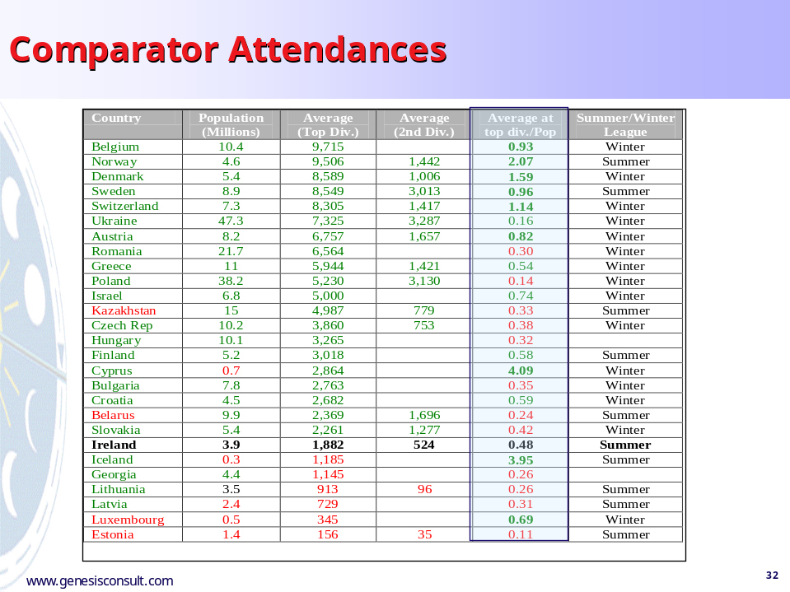

Average population per top league team
Looking at the average population per top league team in some of the comparator European leagues showed that:
- Findings
  - Ireland has a low number of people per league club compared to other leagues (only Norway was lower in our sample set)
  - A figure of 500k+ people is the norm for other leagues
- Key Conclusion
  - This would suggest that fewer clubs (in the right locations) would be the optimum scenario

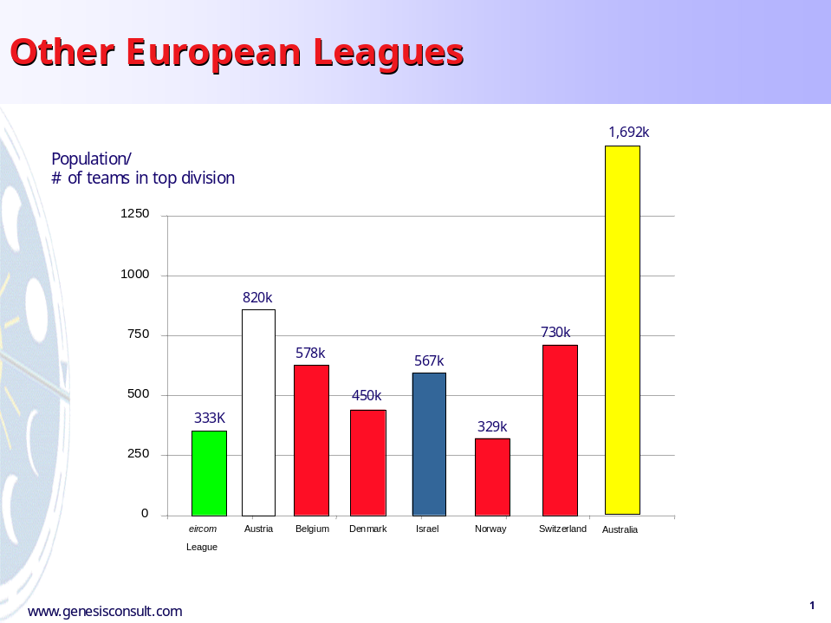

Attendance level growth patterns
The growth patterns of other European leagues showed a mixed performance:
- Findings
  - Austria (36.5%), Norway (20.8%) and Switzerland (16%) are all growing strongly
  - Ireland is showing adequate growth (10%) albeit of a small base
  - Belgium and Sweden are showing declines in attendances
- Key Conclusion
  - Ireland should target a more aggressive growth rate to build a stronger base

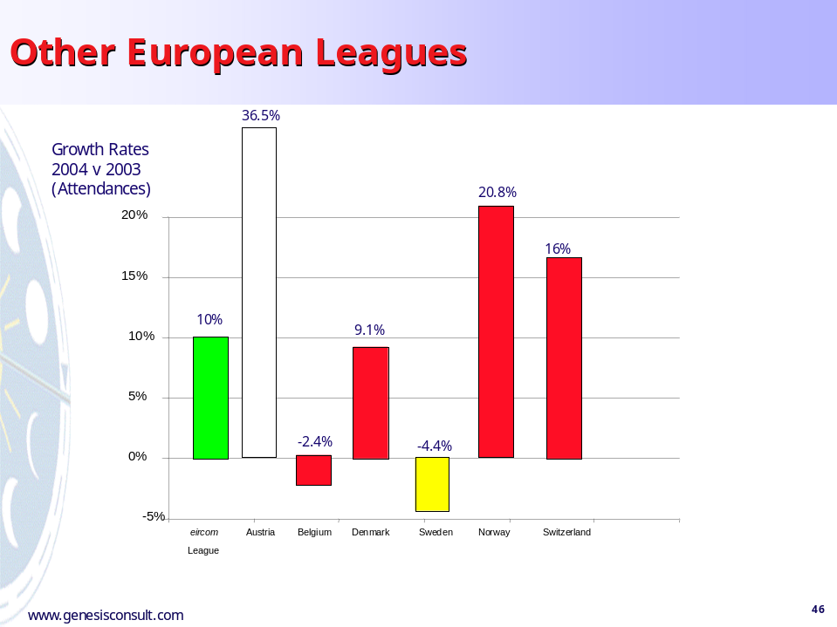

Other Sports Facilities in Ireland
- Findings
  - In virtually every eircom League ground location in Ireland there are better, more attractive competing sports-related facilities on offer for the sports orientated individual
  - Significant investment in facilities has reaped big benefits for other sports, especially Greyhound Racing
  - New markets have been attracted to these sports successfully
- Key Conclusion
  - In order to compete, football needs to invest in high quality facilities
  - The bar has been raised considerably and the eircom League must respond if it is to attract new people to the game

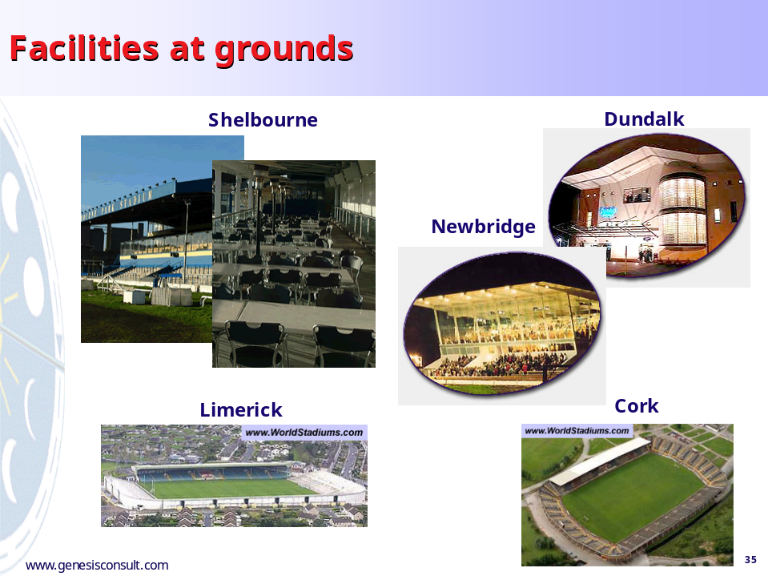

Marketing of Other Sports
- Findings
  - In comparison to other sports the eircom League marketing is low key and less impactful
  - Other sports have made significant strides in popularity, in part, through their effective, high quality marketing initiatives
- Key Conclusion
  - The eircom League must invest in marketing the league properly and to a high standard (assuming the other key components of the mix are being addressed – quality of facilities, standards of play etc.)

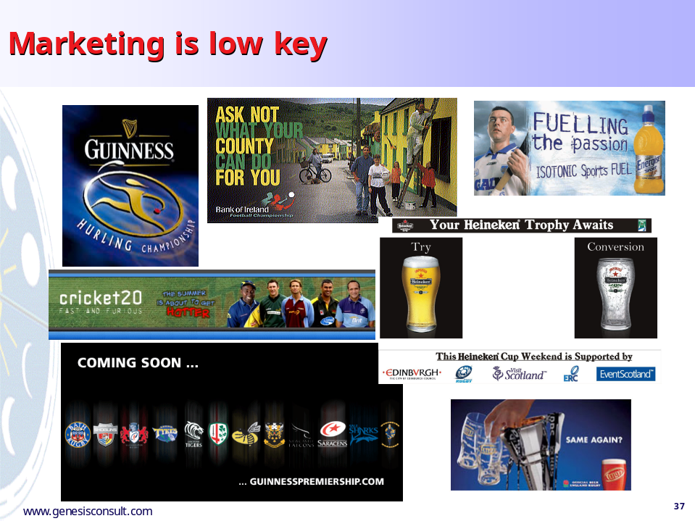
Branding of the ‘Event’
- Findings
  - Other sports are increasingly sophisticated in the manner in which they present and package the event surrounding their games
- Key Conclusion
  - The eircom League does not project a coherent and consistent image for its games in line with other sports
  - As a result, it struggles to attract premium sponsors

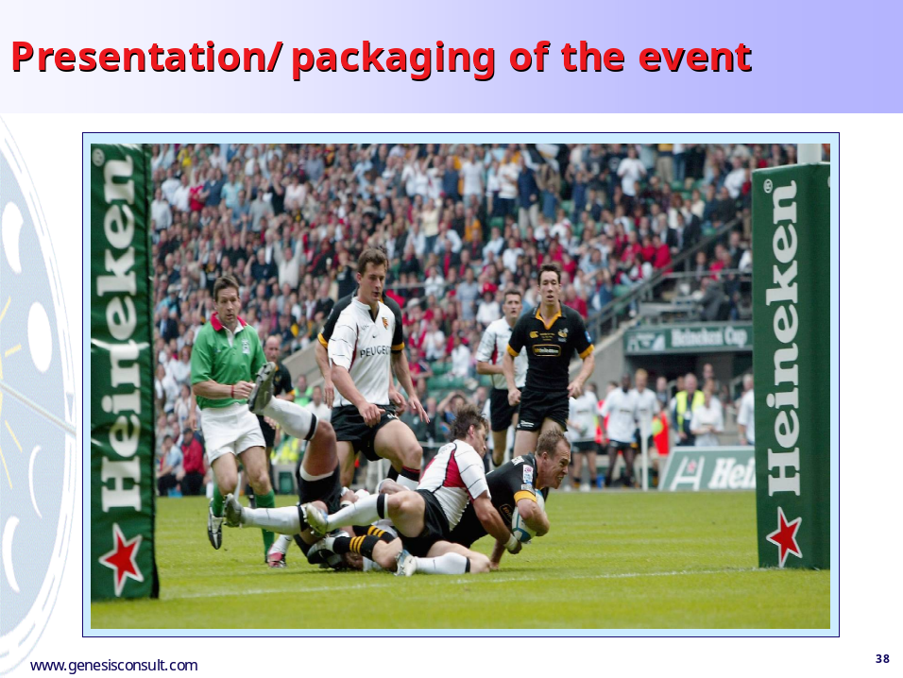

Appendix 2: UEFA and FIFA Rankings

UEFA Domestic League Rankings - Last update: Fri, 26 Aug 2005 17:21:23
# | country | 01/02 | 02/03 | 03/04 | 04/05 | 05/06 | rank06 | nt06
1 | Spain | 14.857 | 15.500 | 14.312 | 12.437 | 2.214 | 59.320 | 7/ 7
2 | Italy | 12.571 | 15.928 | 8.875 | 14.000 | 2.214 | 53.588 | 7/ 7
3 | England | 11.571 | 10.666 | 11.250 | 15.571 | 2.714 | 51.772 | 7/ 7
4 | France | 7.125 | 7.916 | 13.500 | 11.428 | 0.812 | 40.781 | 8/ 8
5 | Germany | 13.500 | 9.142 | 4.714 | 10.571 | 1.687 | 39.614 | 8/ 8
6 | Portugal | 9.375 | 10.750 | 10.250 | 8.166 | 1.000 | 39.541 | 6/ 6
7 | Netherlands | 10.166 | 6.166 | 5.416 | 12.000 | 1.250 | 34.998 | 6/ 6
8 | Greece | 11.250 | 7.166 | 4.166 | 6.166 | 1.166 | 29.914 | 6/ 6
9 | Scotland | 6.625 | 7.375 | 7.375 | 4.750 | 1.750 | 27.875 | 2/ 4
10 | Belgium | 5.875 | 6.875 | 5.875 | 6.125 | 3.000 | 27.750 | 4/ 4
11 | Turkey | 5.625 | 4.666 | 6.500 | 5.375 | 1.500 | 23.666 | 3/ 4
12 | Russia | 2.333 | 3.625 | 5.875 | 10.000 | 1.250 | 23.083 | 4/ 4
13 | Czech Republic | 5.500 | 6.200 | 7.375 | 2.875 | 1.125 | 23.075 | 4/ 4
14 | Ukraine | 3.625 | 4.250 | 4.875 | 8.100 | 1.250 | 22.100 | 3/ 4
15 | Israel | 8.333 | 5.833 | 2.250 | 3.625 | 1.000 | 21.041 | 1/ 4
16 | Austria | 3.375 | 4.000 | 2.125 | 7.625 | 2.750 | 19.875 | 3/ 4
17 | Switzerland | 6.125 | 5.875 | 1.875 | 2.625 | 2.625 | 19.125 | 4/ 4
18 | Norway | 3.250 | 2.700 | 6.125 | 3.500 | 2.800 | 18.375 | 5/ 5
19 | Poland | 4.125 | 6.625 | 4.125 | 2.500 | 0.875 | 18.250 | 2/ 4
20 | Serbia-Montenegro | 3.166 | 4.833 | 4.500 | 4.250 | 1.500 | 18.249 | 2/ 4
21 | Bulgaria | 4.833 | 4.166 | 4.166 | 2.375 | 1.500 | 17.040 | 4/ 4
22 | Romania | 2.625 | 2.166 | 4.333 | 5.500 | 2.166 | 16.790 | 3/ 3
23 | Denmark | 4.500 | 3.250 | 4.200 | 1.500 | 2.000 | 15.450 | 3/ 4
24 | Hungary | 1.500 | 3.166 | 4.833 | 4.166 | 1.000 | 14.665 | 1/ 3
25 | Croatia | 4.375 | 2.750 | 3.625 | 3.000 | 0.333 | 14.083 | 3
26 | Sweden | 3.833 | 2.250 | 1.500 | 3.000 | 1.333 | 11.916 | 2/ 3
27 | Slovakia | 3.500 | 0.666 | 2.500 | 1.333 | 2.666 | 10.665 | 1/ 3
28 | Cyprus | 1.333 | 3.166 | 1.333 | 1.333 | 3.000 | 10.165 | 2/ 3
29 | Slovenia | 1.500 | 0.666 | 2.166 | 3.500 | 1.666 | 9.498 | 1/ 3
30 | Bosnia-Herzegovina | 0.333 | 3.000 | 1.666 | 1.666 | 1.500 | 8.165 | 1/ 3
31 | Latvia | 0.666 | 1.166 | 0.833 | 3.166 | 1.333 | 7.164 | 3
32 | Finland | 1.375 | 0.333 | 1.666 | 1.666 | 2.000 | 7.040 | 1/ 3
33 | Moldova | 1.166 | 1.000 | 1.500 | 1.500 | 1.666 | 6.832 | 3
34 | Georgia | 1.333 | 1.333 | 0.333 | 2.666 | 0.666 | 6.331 | 3
35 | Lithuania | 0.333 | 0.833 | 0.833 | 2.500 | 1.333 | 5.832 | 3
36 | Macedonia | 0.666 | 1.166 | 1.666 | 0.333 | 1.500 | 5.331 | 3
37 | Iceland | 0.833 | 0.166 | 0.500 | 2.500 | 0.833 | 4.832 | 3
38 | Liechtenstein | 0.500 | 1.000 | 0.000 | 2.000 | 1.000 | 4.500 | 1
39 | Belarus | 0.750 | 1.166 | 0.666 | 0.500 | 1.333 | 4.415 | 3
40 | Ireland | 0.666 | 0.166 | 0.333 | 1.333 | 1.833 | 4.331 | 1/ 3
41 | Albania | 0.666 | 0.666 | 0.333 | 1.000 | 1.000 | 3.665 | 3
42 | Armenia | 0.000 | 1.166 | 0.666 | 0.500 | 0.666 | 2.998 | 3
43 | Estonia | 0.500 | 0.166 | 0.333 | 0.833 | 0.833 | 2.665 | 3
44 | Malta | 1.166 | 0.833 | 0.333 | 0.333 | 0.000 | 2.665 | 3
45 | Wales | 1.000 | 0.333 | 0.333 | 0.000 | 0.666 | 2.332 | 3
46 | Northern Ireland | 0.333 | 0.333 | 0.500 | 0.666 | 0.500 | 2.332 | 3
47 | Azerbaijan | 0.166 | 0.000 | 0.000 | 0.500 | 1.333 | 1.999 | 3
48 | Luxembourg | 0.333 | 0.500 | 0.166 | 0.333 | 0.500 | 1.832 | 3
49 | Kazakhstan | 0.000 | 0.500 | 0.166 | 0.000 | 1.000 | 1.666 | 1
50 | Faroe Islands | 0.500 | 0.166 | 0.000 | 0.333 | 0.666 | 1.665 | 3
51 | Andorra | 0.000 | 0.000 | 0.000 | 0.000 | 0.000 | 0.000 | 1
52 | San Marino | 0.000 | 0.000 | 0.000 | 0.000 | 0.000 | 0.000 | 1

The UEFA country ranking is determined by the sum of the UEFA country coefficients over the last 5 years. The column 'nt06' lists the number of participating teams this season. In the current season also the number of teams still in competition is listed (and indicated by colour).

FIFA World Rankings - Last update: Sept 2005
Rank | Team | +/-Rank  Aug 05 | Pts:  Sep 05 | +/-Pts: Aug 05
1 | Brazil | 0 | 839 | 2
2 | Netherlands | 1 | 785 | 5
3 | Argentina | -1 | 778 | -4
4 | Czech Republic | 0 | 777 | 0
5 | Mexico | 0 | 771 | 1
6 | France | 3 | 770 | 33
7 | USA | -1 | 768 | 0
8 | Spain | 0 | 750 | 11
9 | Portugal | 0 | 743 | 6
10 | Sweden | 5 | 740 | 32
11 | England | -4 | 738 | -5
12 | Turkey | 0 | 731 | 19
13 | Italy | 0 | 725 | 14
14 | Denmark | 4 | 721 | 25
15 | Germany | -4 | 718 | -4
16 | Japan | 1 | 716 | 10
17 | Poland | 5 | 705 | 17
18 | Iran | -3 | 702 | -6
19 | Costa Rica | 2 | 700 | 8
20 | Greece | -2 | 699 | 3
21 | Republic of Ireland | -7 | 694 | -15
22 | Cameroon | 6 | 688 | 25
23 | Tunisia | 8 | 687 | 38
24 | Croatia | -4 | 686 | -7
25 | Uruguay | 0 | 680 | 5
26 | Colombia | -2 | 677 | -1
26 | Korea Republic | -3 | 677 | -4
28 | Saudi Arabia | -1 | 675 | 10
29 | Nigeria | 1 | 672 | 22
30 | Russia | -1 | 669 | 14
Rank | Team | +/-Rank  Aug 05 | Pts:  Sep 05 | +/-Pts: Aug 05
31 | Egypt | -5 | 662 | -9
32 | Romania | -1 | 660 | 11
33 | Ecuador | 0 | 658 | 10
34 | Paraguay | 1 | 656 | 16
35 | Senegal | 5 | 652 | 24
36 | Morocco | -2 | 649 | 7
37 | Norway | -1 | 647 | 8
38 | Switzerland | 4 | 643 | 21
39 | Ukraine | -3 | 636 | -3
40 | Finland | 3 | 629 | 12
41 | Jamaica | 0 | 623 | -3
42 | South Africa | -4 | 622 | -10
43 | Honduras | -4 | 620 | -11
44 | Israel | 3 | 616 | 20
45 | Bulgaria | 1 | 613 | 7
45 | Slovakia | 0 | 613 | 2
47 | Belgium | 5 | 608 | 23
48 | Serbia and Montenegro | 1 | 601 | 8
49 | Zimbabwe | 2 | 598 | 11
50 | Australia | 7 | 593 | 25
50 | Côte d'Ivoire | -6 | 593 | -23
52 | Slovenia | -4 | 590 | -5
53 | Bahrain | -3 | 588 | -3
54 | Togo | 12 | 585 | 30
55 | Mali | 5 | 578 | 12
56 | Trinidad and Tobago | -3 | 577 | 3
57 | Guatemala | 2 | 571 | 4
57 | Uzbekistan | 5 | 571 | 10
57 | Venezuela | 10 | 571 | 21
60 | China PR | -6 | 569 | -3

Rank | Team | +/-Rank  Aug 05 | Pts:  Sep 05 | +/-Pts: Aug 05
61 | Kuwait | -7 | 567 | -5
62 | Ghana | 8 | 566 | 19
63 | Latvia | 1 | 564 | 5
64 | Zambia | -8 | 563 | -6
65 | Angola | 6 | 562 | 16
66 | Hungary | -1 | 557 | 0
67 | Bosnia-Herzegovina | 11 | 555 | 22
68 | Iraq | -11 | 554 | -14
69 | Jordan | -6 | 552 | -8
70 | Peru | 5 | 551 | 8
71 | Belarus | -10 | 548 | -17
72 | Congo DR | 7 | 545 | 17
73 | Cuba | 1 | 544 | 0
74 | Scotland | 12 | 542 | 38
75 | Qatar | -7 | 541 | -8
76 | Chile | -3 | 538 | -7
76 | Panama | 1 | 538 | -2
78 | Oman | -10 | 537 | -12
79 | Austria | -8 | 533 | -13
80 | Libya | -5 | 532 | -11
81 | Estonia | 1 | 526 | 8
82 | Wales | 1 | 521 | 4
83 | Algeria | -2 | 519 | -2
84 | Canada | 0 | 516 | 3
85 | Korea DPR | 4 | 515 | 17
86 | Albania | 1 | 514 | 15
87 | Kenya | -7 | 509 | -16
88 | United Arab Emirates | -3 | 508 | 0
89 | Burkina Faso | 2 | 504 | 15
89 | Guinea | 1 | 504 | 8
Rank | Team | +/-Rank  Aug 05 | Pts:  Sep 05 | +/-Pts: Aug 05
91 | Haiti | -4 | 500 | 1
92 | Iceland | 2 | 493 | 7
93 | Sudan | 9 | 491 | 24
94 | Thailand | 1 | 485 | 0
95 | Lithuania | -3 | 476 | -12
96 | Botswana | 5 | 475 | 3
96 | Indonesia | 1 | 475 | -3
96 | FYR Macedonia | -4 | 475 | -13
99 | Singapore | 0 | 474 | 0
100 | Bolivia | 0 | 469 | -4
101 | Northern Ireland | 15 | 464 | 54
102 | Syria | -6 | 463 | -18
103 | Cyprus | 2 | 462 | 19
104 | Georgia | -1 | 461 | 1
105 | Gabon | -7 | 460 | -16
106 | Rwanda | -2 | 456 | -1
107 | Moldova | 6 | 436 | 22
108 | Malawi | 0 | 432 | -2
109 | Turkmenistan | -2 | 428 | -9
110 | Uganda | 0 | 423 | 0
111 | New Zealand | -2 | 420 | -11
112 | Vietnam | -6 | 417 | -24
113 | Congo | -2 | 415 | -2
114 | Azerbaijan | 2 | 411 | 1
115 | Armenia | 5 | 408 | 18
116 | Malaysia | -5 | 406 | -11
117 | St. Lucia | 1 | 403 | -2
118 | El Salvador | -3 | 398 | -14
118 | Lebanon | -5 | 398 | -16
120 | Hong Kong | -1 | 394 | 3

Rank | Team | +/-Rank  Aug 05 | Pts:  Sep 05 | +/-Pts: Aug 05
121 | Barbados | -1 | 389 | -1
122 | Cape Verde Islands | 1 | 386 | 7
123 | Liechtenstein | 16 | 375 | 44
124 | St. Kitts and Nevis | -2 | 373 | -8
125 | Andorra | 9 | 368 | 22
126 | Benin | -1 | 365 | 3
127 | Malta | 11 | 361 | 27
128 | Ethiopia | -1 | 357 | -2
128 | St. Vincent and the Grenadines | 0 | 357 | -1
130 | Mozambique | 0 | 356 | 4
131 | Yemen | -7 | 351 | -25
132 | Liberia | -2 | 348 | -4
132 | Swaziland | -3 | 348 | -6
134 | Faroe Islands | -8 | 344 | -16
134 | India | -2 | 344 | -6
136 | Palestine | -3 | 341 | -8
137 | Tahiti | -2 | 337 | -8
138 | Solomon Islands | -2 | 336 | -3
139 | Fiji | -2 | 334 | -4
140 | Tajikistan | 1 | 314 | -7
141 | Myanmar | 3 | 313 | 2
142 | Burundi | 1 | 311 | -2
142 | Maldives | 0 | 311 | -9
142 | Sri Lanka | -2 | 311 | -14
145 | Mauritius | -1 | 306 | -5
146 | Kazakhstan | 2 | 304 | 8
147 | Lesotho | -1 | 298 | -7
148 | Vanuatu | -1 | 293 | -6
149 | Grenada | 0 | 281 | -7
Rank | Team | +/-Rank  Aug 05 | Pts:  Sep 05 | +/-Pts: Aug 05
150 | Madagascar | 0 | 273 | -7
151 | Surinam | 0 | 269 | -6
152 | Kyrgyzstan | 0 | 262 | -6
153 | Antigua and Barbuda | 1 | 252 | -1
153 | Chinese Taipei | 0 | 252 | -8
155 | Luxembourg | 0 | 246 | -6
156 | Nicaragua | 0 | 244 | 0
157 | Chad | 0 | 237 | -3
158 | Bermuda | -1 | 236 | -4
159 | Namibia | 0 | 233 | -4
160 | Gambia | 0 | 230 | -6
161 | San Marino | 0 | 228 | -1
162 | Sierra Leone | 0 | 214 | -4
163 | British Virgin Islands | 1 | 212 | -2
164 | Laos | -1 | 211 | -6
165 | Papua New Guinea | 0 | 209 | -4
166 | Netherlands Antilles | 0 | 201 | -4
167 | Dominica | 0 | 193 | -4
168 | Bangladesh | 0 | 190 | -5
169 | Pakistan | 0 | 184 | -2
170 | Eritrea | -1 | 181 | -5
171 | Equatorial Guinea | 0 | 180 | -2
172 | Dominican Republic | 0 | 174 | -4
173 | Seychelles | 1 | 163 | -3
174 | Tanzania | -1 | 162 | -5
175 | Niger | 0 | 159 | -3
176 | Mauritania | 0 | 154 | -3
177 | Cayman Islands | 0 | 152 | -2
178 | Samoa | 0 | 148 | -3
179 | Nepal | -1 | 147 | -4
Rank | Team | +/-Rank  Aug 05 | Pts:  Sep 05 | +/-Pts: Aug 05
180 | Belize | 0 | 140 | -1
180 | Mongolia | 0 | 140 | -1
182 | Guyana | -2 | 139 | -2
183 | Central African Republic | 0 | 138 | -2
184 | Tonga | 0 | 122 | -3
185 | New Caledonia | 0 | 111 | -1
186 | Cambodia | 0 | 109 | -2
187 | Philippines | 0 | 93 | -1
188 | Somalia | 0 | 90 | -1
189 | Bhutan | 0 | 89 | -1
190 | Macau | 0 | 83 | -2
191 | Guinea-Bissau | 0 | 80 | -3
192 | Bahamas | 0 | 78 | -2
193 | Cook Islands | -1 | 77 | -3
194 | Puerto Rico | 0 | 73 | 0
195 | US Virgin Islands | 0 | 65 | -1
196 | São Tomé e Príncipe | -1 | 64 | -2
197 | Anguilla | 0 | 58 | -1
198 | Brunei Darussalam | 0 | 55 | -2
199 | Aruba | 0 | 54 | -2
200 | Afghanistan | 0 | 53 | -1
201 | Djibouti | 0 | 36 | -1
202 | Montserrat | 0 | 34 | -1
203 | Turks and Caicos Islands | 0 | 25 | 0
204 | Guam | 0 | 20 | 0
205 | American Samoa | 0 | 16 | -1

Appendix 3: The External Environment
Shifting trends in football
Fundamental changes have taken place in the wider football industry over the last ten years that have a major impact on the environment in which the eircom League must operate:
- The commercialization of international football and European football in particular has led to rapid changes in the industry. These dramatic changes have been most pronounced in England with the emergence of the English Premiership. The “Sky Sports” era has led to saturation coverage and high profile marketing of the major European football leagues. Coupled with this, the establishment of the Champions League has further driven the incessant commercialization of football at the highest levels in Europe.
- The Bosman ruling has led to the accelerated international movement of players and led to reduced transfer payments to smaller clubs.
- Considerable investment has taken place as a result of events such as Hillsborough and Hyssel. The overall standard of stadia and facilities has improved dramatically. The days of open terraces and basic amenities have been replaced with all-seater stadia and corporate hospitality suites.
- The rich leagues and clubs are getting richer and the poor, poorer. More revenue is being shared amongst fewer clubs in a smaller number of larger countries.
- The competition for Ireland, in the 2nd tier of football nations, has intensified. Many emerging nations are now challenging Ireland high ranking in international football. All have stronger domestic leagues in comparison to Ireland.
- Most Irish football supporters are active followers of the English Premiership and the number of ‘day trippers’ to the UK and Scotland is rivaling the weekly attendance figures of the eircom League.

Changes in the UK
The professional league in the UK is undergoing specific changes which are directly relevant to the eircom League:
- The Premiership is the richest domestic league in the world.
- There has been a huge influx of foreign talent into the Premiership (there are currently 252 foreign players playing in the Premiership – that’s an average of 12.6 per club).
- UEFA regulations will limit the number of foreign players in any team squad (at least 8 home grown players in 25 man squad by 2008). This will limit the opportunities for Irish players to develop in the UK.
- Traditionally, approximately 30 youngsters (15-17 year-olds) would sign for UK based clubs annually – this figure is now closer to 10 and declining.
- There has been a re-calibration of wage expectations in the lower leagues in the UK. Outside of the Premiership’s top clubs and players, wages & contracts have been significantly re-aligned.

UEFA Perspective
UEFA are increasingly taking more regulatory control in the affairs of domestic football in Europe:
- The introduction of club licensing is raising the bar for all European league clubs in all aspects of operations:
  - Sporting, Infrastructure, Personnel, Administration, Legal, Finance
- UEFA have strong views on the running of domestic leagues/football:
  - UEFA are pushing for national associations to control their own national domestic leagues. This is in reaction to the emergence of the G14/16 and the threat of a breakaway European league.
  - They believe elite, professional, semi-professional and amateur football are inextricably linked through the pyramid and each level supports the other level.
  - They have set the development of club football as a key priority and are providing support
    - e.g. European Club Forum.
  - 2005 Congress approved a more interventionist strategy for UEFA in the development of football in Europe over the next decade.

The competitive environment in Ireland
The eircom League is competing with a range of strong/revitalised sports in Ireland.
- GAA
  - The GAA has reinvented itself and is ‘chic’.
  - The Championship branding & marketing is very powerful and high quality
  - 2.2m are attending Championship games, although there is evidence to suggest that attendances are tailing off.
  - Media exposure and coverage is widespread and dominates the local sporting landscape throughout the Summer.
  - The GAA’s community linkages remain dominant and very strong.
- Rugby
  - The professional game is thriving in terms of exposure and attendances.
  - The Heineken Cup has 48 live broadcasts between Sky & RTE and overall attendances of 815k in 2004 & growing.
  - The Celtic League is enjoying attendances of 424k in 2004.
- Greyhound Racing
  - The industry has undergone a transformation of image due to its investment in facilities. Throughout the country Bord na gCon have invested in upgrading their facilities and now enjoy a range of high quality venues.
  - The industry has implemented a focused marketing strategy that has delivered impressive results:
    - Captured a new target audience
    - 1.385m attending meetings in 2004
    - Sponsorship income up by 18% for the first 6 months of this year (€830k) – the eircom League only attracted €587k in sponsorship last year.
- Horse Racing
  - Ireland continues to enjoy a strong Horse Racing industry.
  - Courses are investing in their facilities.
  - 1.3m are attending meetings annually.
  - Commercial sponsorship continues to rise (10% last year to €5.35m).
  - Prize money rising rapidly (67% last year) to €51.46m.

Societal changes in Ireland
Ireland has been one of the strongest and fastest growing economies in the World. This has brought about a range of societal changes, for example:
- Irish society is becoming “cash rich, time poor” and there is a premium placed on leisure time. At the same time there are an increasingly diverse range of leisure pursuits available to people.
- There are higher expectations in standards/service. This is compounded by the “Sky Sports” era with access to and availability of high quality professional sports events/products at any time of the year.
- There has bee a marked increase in obesity, unhealthy eating and sedentary lifestyles.
- Increasingly there is a stronger focus on regulation and compliance e.g. tax compliance, corruption tribunals, NCT, smoking ban, bogus non resident accounts etc.
- The role of politics in sport (and football in particular!) is getting stronger. Politicians are becoming:
  - more demanding in terms of change
  - and less supportive in funding.

Appendix 4: Options for League Structure
A range of options for the league structure were developed, debated and evaluated. Within each of the options developed were any number of variants based on minor changes to the numbers and structures. The core options considered included:
1. The Status Quo
- 2 divisions of 22 clubs
- Promotion and relegation the two divisions
- No link to other leagues
2. Status Quo Plus
- 2 divisions of 22 clubs
- Promotion and relegation between the two divisions
- Promotion and relegation mechanism between other leagues and the 2nd division
- Smaller number of clubs in the top division versus the second division (e.g. 10 and 12)
3. The Franchise
- Closed franchised league of 14, 12 or 10 teams
- No promotion and relegation
- Franchises awarded based on specific criteria
- Spread of clubs across the country and major population centres
4. The Elite League
- A single National League of 10 teams
- Two Regional leagues below the National League with 10 teams in each Regional League
- Promotion and relegation between the top league and the Regional leagues via an end-of-season play-off system
- Promotion and relegation mechanism between the Regional leagues and the Amateur leagues
- Minimum criteria would be set for participation in the National League.
5. Single League
- A single National League of 16 teams
- No regional league structure
- Promotion and relegation mechanism between the League and the Amateur leagues
6. All Ireland League
- All Ireland League with teams from the South and North (say 8 and 4)
- Three Regional leagues below the All Ireland League with 10 or 12 teams in each league
- Promotion and Relegation between the All Ireland and Regional leagues via end-of-season play-offs
- Minimum criteria for participation in the league
- Promotion and Relegation mechanism between the Regional leagues and Amateur leagues
7. Celtic/Islands League
- A cross border league involving teams from Ireland, Northern Ireland, Wales and possibly Scotland of up to 20 teams
- National league involving the remaining clubs not participating ion the Celtic League
- Promotion and Relegation between the Celtic League and the national leagues
- Promotion and Relegation between the National League and the Amateur leagues

As outlined above, we developed a list of ten criteria for evaluating the various options:
  - Optimise the commercial potential of the league
  - Improve the competitiveness of clubs in Europe
  - Provide high quality football (“the best of Irish”)
  - Represent a new beginning for the league
  - More attractive for private investment
  - More attractive for public investment
  - Provide a pinnacle for the development pathway for the game locally
  - Support the strengthening of the international team
  - Minimise costs of participation for clubs
  - Provide an adequate geographic spread of league clubs.

Appendix 5: List of those Consulted
We have carried out an extensive consultation with all stakeholders in the game to establish their views. All those we met/spoke with are listed below. We ensured that all interested parties were given a chance to have their say and express their views and ideas.

League Staff & Officials
Michael Hayes, General Manager
Aidan Doyle, Marketing Manager
Andy Needham, Media and PR
Pat Duffy, Under 21 League Manager
Paula O’Brien, PA to the General Manager
Paddy McCaul, Chairman
Aine McNulty, Administrator
Eamonn Naughton, Treasurer

FAI Staff
Bob Breen, Club Licensing
Packie Bonner, Technical Director
Brian Kerr, International Team Manager
John Byrne, Football Development Manager
Paul Brady, Domestic Department
Eoin Hand, Career Guidance Counselor
Milo Corcoran, President
John Delaney, CEO
Michael Hyland, ex-Chairman of the eircom League
Declan Conroy, Strategy Director
Pat Kelly, Referee Department
Mark O’Leary, Finance Director

Clubs
Olly Byrne, Shelbourne
Jack O’Neill, Bray Wanderers
Paddy Martin, Drogheda
Andy O’Callaghan, St Pats
Bernard O’Byrne, St Pats
Paul Garrigan, St Pats
Gerry Cuffe, Bohemians
Sean Connolly, Dundalk
Eddie Murray, Monaghan United
Jim McGlone, Monaghan United
Jim Roddy, Derry City
John McNulty, Finn Harps
Brian Lennox, Cork City
Noel Hanley, Limerick City
Danny Drew, Limerick City
Ray Scott, Waterford United
Greg Pheasey, Waterford United
Barry Walsh, Cobh Ramblers
Nial O’Reilly, Galway United

Broadcasters
Laurence St John, TV Rights Consultant/Advisor to the FAI
Tim Twomey, Setanta Sports
Matthew Salway. TV3
Glen Killane, RTE
Steven Hawkins, RTE
Ronan Ó’Coisdealbha, TG4

Media
Aidan Fitzmaurice, Evening Herald
Paul Buttner, Freelance
Michael Scully, Irish Daily Mirror
Owen Cowzer, Irish Examiner
Gerry McDermott, Independent Newspapers
Paul Lennon, Daily Star
Pat Dolan, Daily Star and TV Analyst

Players
Fran Gavin, General Secretary of the PFAI

Managers
Alan Matthews, League Managers Association

Amateur/Schoolboy Representatives
John Sherlock, Roscommon and District Schoolboy League
Noel Kennedy, Connacht FA
Tom Lewis, Tipperary Southern and District League
John Coughlan, Leinster Football Association
Fran Ray, Dublin Amateur Schoolboy League
Tommy Heffernan, Dublin Amateur Schoolboy League
Noel Kennelly, Chairman of the FAI Rules Commission

Supporters
James O’Toole, National League Supporters Association

Sponsors
Paraic Corkery, eircom
John Courtenay, Umbro
Patrick Peyton, Umbro
Jonathon Courtenay, Umbro
John Givens, Lucozade Sport

Other Stakeholders
Information from UEFA & FIFA
Andy Roxburgh, Technical Director UEFA
Mitch Whitty, Shamrock Rovers
John Treacy, CEO Irish Sports Council
Con Haugh, Department of Arts, Sport and Tourism

Research on Other Leagues
Australia
Austria
Belgium
Denmark
Israel
Izhak Iche Menachem, Chairman, The Israel Football Association
Avi Luzon, Deputy Chairman, The Israel Football Association
Norway
Sweden
Switzerland
Guinness (Zurich) Premiership
Super League
20/20 Cricket

